**UML DIAGRAMS FOR MYGYM WEBSITE PROJECT.**

**1.**Activity Diagram

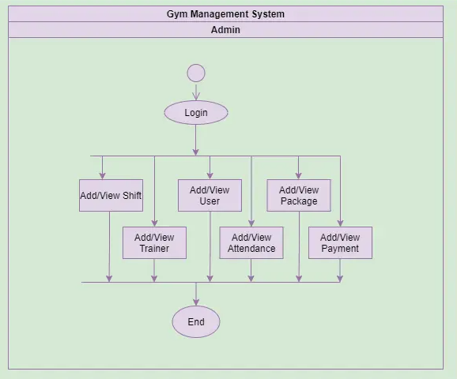

**2.**Sequence diagram

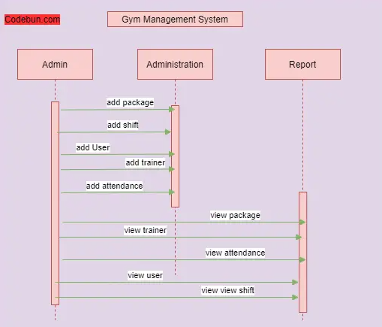

**3.**Component Diagram

